**Ideation Phase**

**Brainstorm & Idea Prioritization Template**

|  |  |
| --- | --- |
| Date | 27 June 2025 |
| Team ID | LTVIP2025TMID29382 |
| Project Name | Smart SDLC-AI-Enhanced Software Development Life Cycle |
| Maximum Marks | 4 Marks |

**Brainstorm & Idea Prioritization:**

Idea Prioritization of Smart SDLC:

Smart SDLC (Software Development Life Cycle), idea prioritization refers to the structured process of selecting and ranking features, improvements, or project ideas based on their value, feasibility, and impact. It helps teams focus on what matters most and ensures efficient use of time and resources.

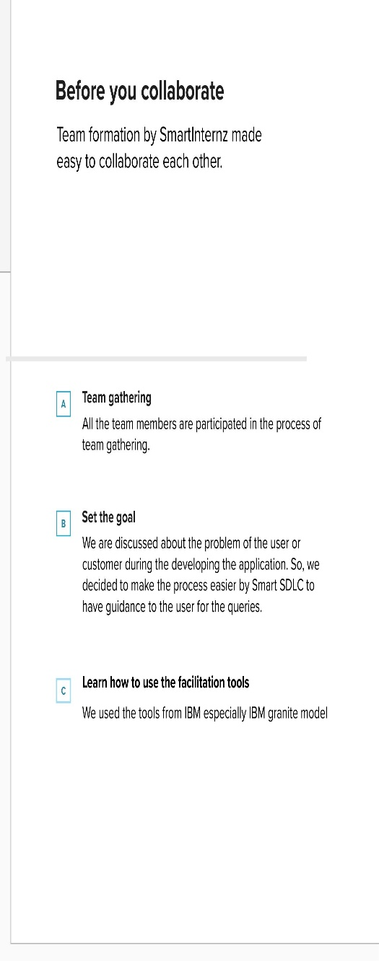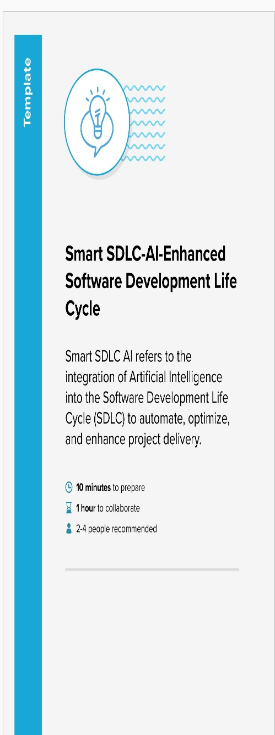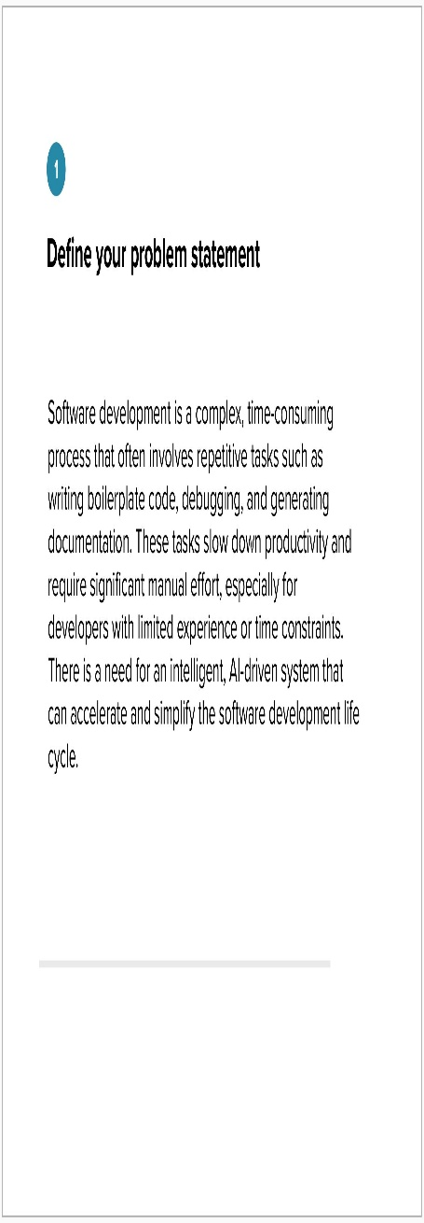**Step-1: Team Gathering, Collaboration and Select the Problem Statement**

**Step-2: Brainstorm, Idea Listing and Grouping**

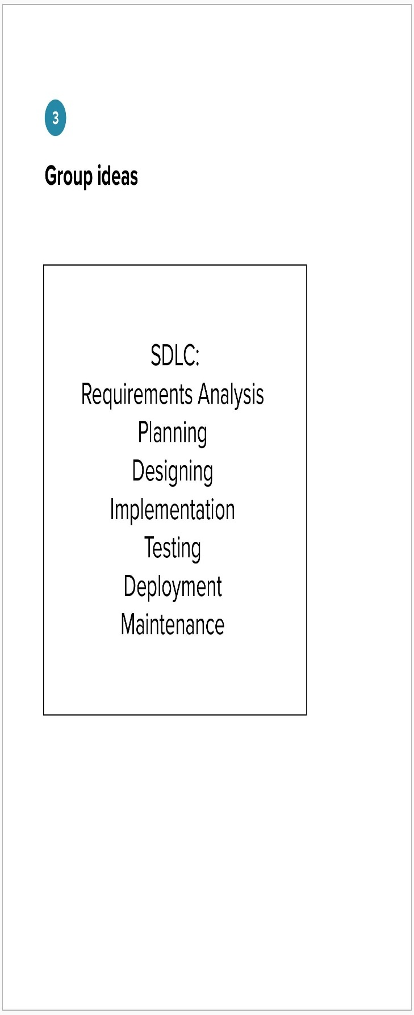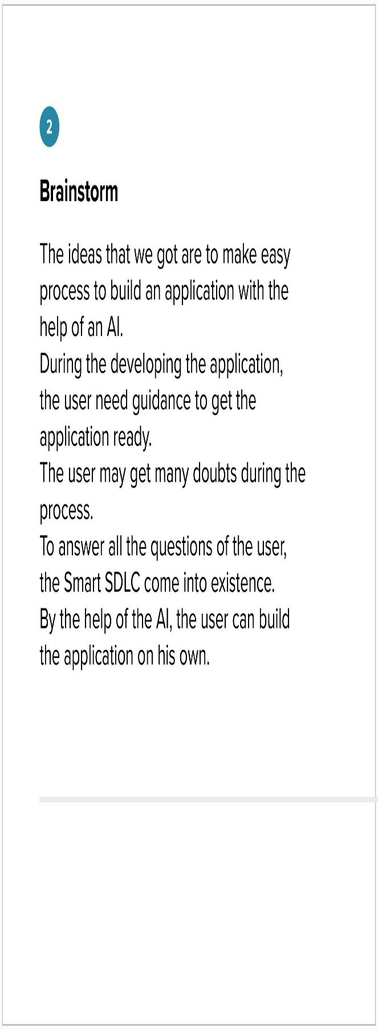

**Step-3: Idea Prioritization**

